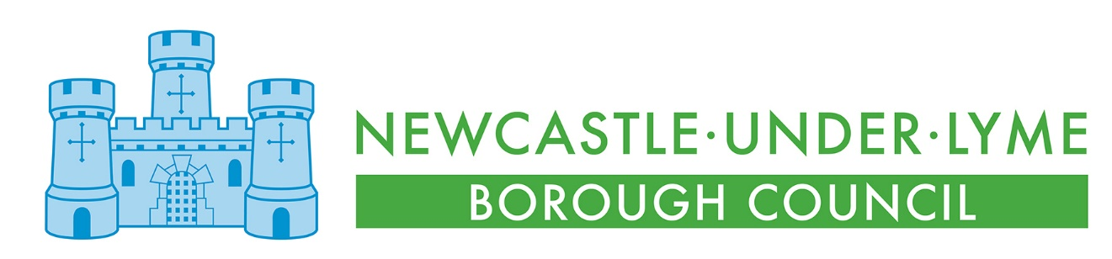

Newcastle Bereavement Services
OBITUS Pricing
1 April 2021 – 31 March 2022

SERVICE | DESCRIPTION | PRICE  (inc. VAT)
Webcast Services
Live | A high-quality live webcast, viewed via our secure, easy-to-use website | £31.00
Live + 28 day + Downloadable | The live webcast, plus access to a recording of the webcast to watch again for a further 28 days | £46.00
Keepsake copy of Webcast | A recording of the webcast on a DVD, Blu-Ray, USB memory stick or audio CD, in a customised case | £51.00
Visual Tribute Pricing
Single Photo | A single photo (shown throughout the service) | £12.50
Slideshow | A slideshow of up to 25 photos (played on a loop throughout, or once at a time of your choosing) | £39.00
Pro Tribute | A pro tribute of up to 25 photos, set to music of your choice (played once at a time of your choosing) | £71.00
Family-Made Video Checking | Checking and preparation of a video supplied by the family or a third party (played once at a time of your choosing) | £19.00
Keepsake Copy of Pro Tribute | A recording of the Pro Photo Tribute on a DVD, Blu-Ray or USB, in a customized case | £24.00
Downloadable Pro Tribute | A recording of the Pro Photo Tribute available to download from our website | £11.00
Variances
Additional Physical Copies | For each extra copy of DVD, Blu-Ray, USB stick or CD of anything already ordered | £24.00
Each Extra 25 Photos | For each extra 25 photos on a "Slideshow" or "Pro Tribute" | £22.00
Extra Work | For adding video to the "Pro Tribute", any revisions, or any major departure from a standard product | £22.00

